SYSTEM DOCUMENTATION

Michaela Inventory | MVentory
Company: Varay Global Corporation
Developer: Ron Justin De Guzman
Date Created: January 6, 2026
Last Updated: March 2, 2026
Version: v2.2.6

INTRODUCTION

1.1 Purpose of the System
Michaela Inventory (MVentory) is a web-based IT asset inventory management system designed to monitor, track, and manage company-owned IT assets such as:
- Desktop computers
- Printers
- POS hardware
- CCTV systems
- Network devices
- Peripherals (mouse, keyboard, scanners, etc.)
The system ensures proper tracking of deployment, status, condition, and allocation of assets across offices, warehouses, branches, and boutiques.

1.2 Target Users
- IT Department (Primary Users)
- IT Administrator
- IT Staff

SYSTEM OVERVIEW

2.1 System Objectives
The system aims to:
- Centralize IT asset records
- Monitor asset deployment location
- Track asset condition (New, Deployed, Repair, Pull-out, etc.)
- Track assigned personnel or location
- Maintain historical asset records
- Reduce asset loss and misallocation
- Improve reporting efficiency

2.2 Core Functionalities
- Asset Registration
- Category Management
- Asset Deployment Monitoring
- Status & Condition Tracking
- Location Assignment (Office, Warehouse, Boutique)
- Reporting
- Asset Search & Filtering
- Audit-ready data records

SYSTEM ARCHITECTURE

3.1 Technology Stack
Frontend
- HTML
- Bootstrap 5
- JavaScript
Backend
- PHP
Database
- MySQL
Server Environment
- XAMPP / Apache
- Compatible with shared hosting servers

3.2 System Structure
The system follows a modular structure:
- Dashboard Module
- Asset Management Module
- Category Module
- Deployment Monitoring Module
- Reporting Module
- Authentication Module

INSTALLATION GUIDE

4.1 System Requirements
- PHP 8.x
- MySQL 5.7+
- Apache Server
- XAMPP (for local deployment)

4.2 Installation Steps
- Copy project folder to:
htdocs/
- Open phpMyAdmin.
- Create a new database:
mventory_db
- Import the provided .sql file.
- Open config file:
/config/database.php
- Update database credentials:
  - Host
  - Username
  - Password
  - Database Name
- Open browser:
http://localhost/mventory

DATABASE DOCUMENTATION

5.1 Main Tables

🔹 assets
Stores all IT asset records.
Field | Description
id | Primary Key
asset_id | Unique Asset Code
category_id | Linked to category table
item_name | Asset name
brand | Brand name
model | Model
serial_number | Serial number
specs | Technical specifications
quantity | Total quantity
assigned_to | Deployment location
status | Deployment status
condition | Physical condition
purchase_date | Date purchased
arrival_date | Date received
cost | Asset cost
warranty_cost | Warranty amount
remarks | Additional notes
created_at | Record timestamp

FEATURE DOCUMENTATION

6.1 Dashboard
Displays:
- Total assets
- Deployed assets
- Available assets
- Repair items
- Pull-out items
Provides quick monitoring overview.

6.2 Asset Registration
Allows IT staff to:
- Add new asset
- Edit asset details
- Delete asset (if authorized)
- Update deployment location
- Update status and condition

6.3 Deployment Monitoring
Tracks:
- Office allocation
- Warehouse allocation
- Branch/Boutique allocation
- Assigned department or user
Ensures traceability of asset movement.

6.4 Status Tracking
Status examples:
- Available
- Deployed
- Under Repair
- Pull-out
- Condemned

6.5 Search & Filtering
Allows filtering by:
- Category
- Location
- Status
- Condition
- Date
Improves audit and inventory checking process.

USER WALKTHROUGH (SYSTEM MANUAL)

Login
- Open system URL.
- Enter username and password.
- Click Login.

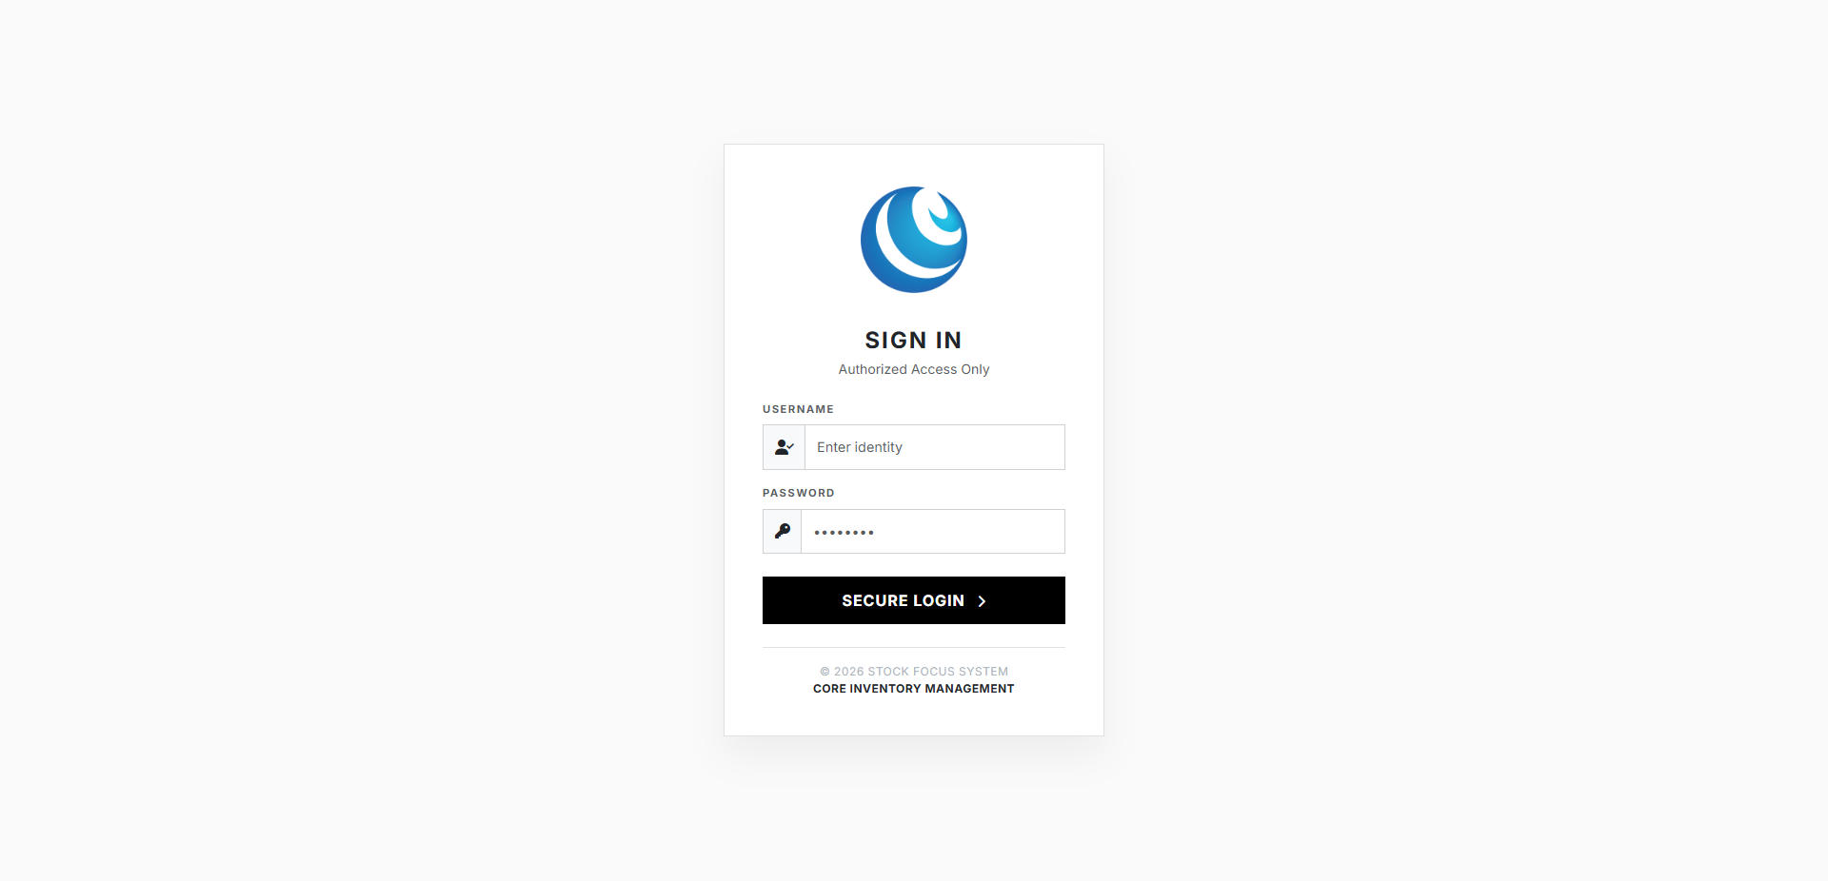
Figure 1: Login.

➕ Adding a New Asset
- Go to "Inventory"
- Click "Add Asset"
- Fill required fields:
  - Asset ID
  - Category
  - Brand
  - Model
  - Serial Number
- Click Save
System automatically records creation date.
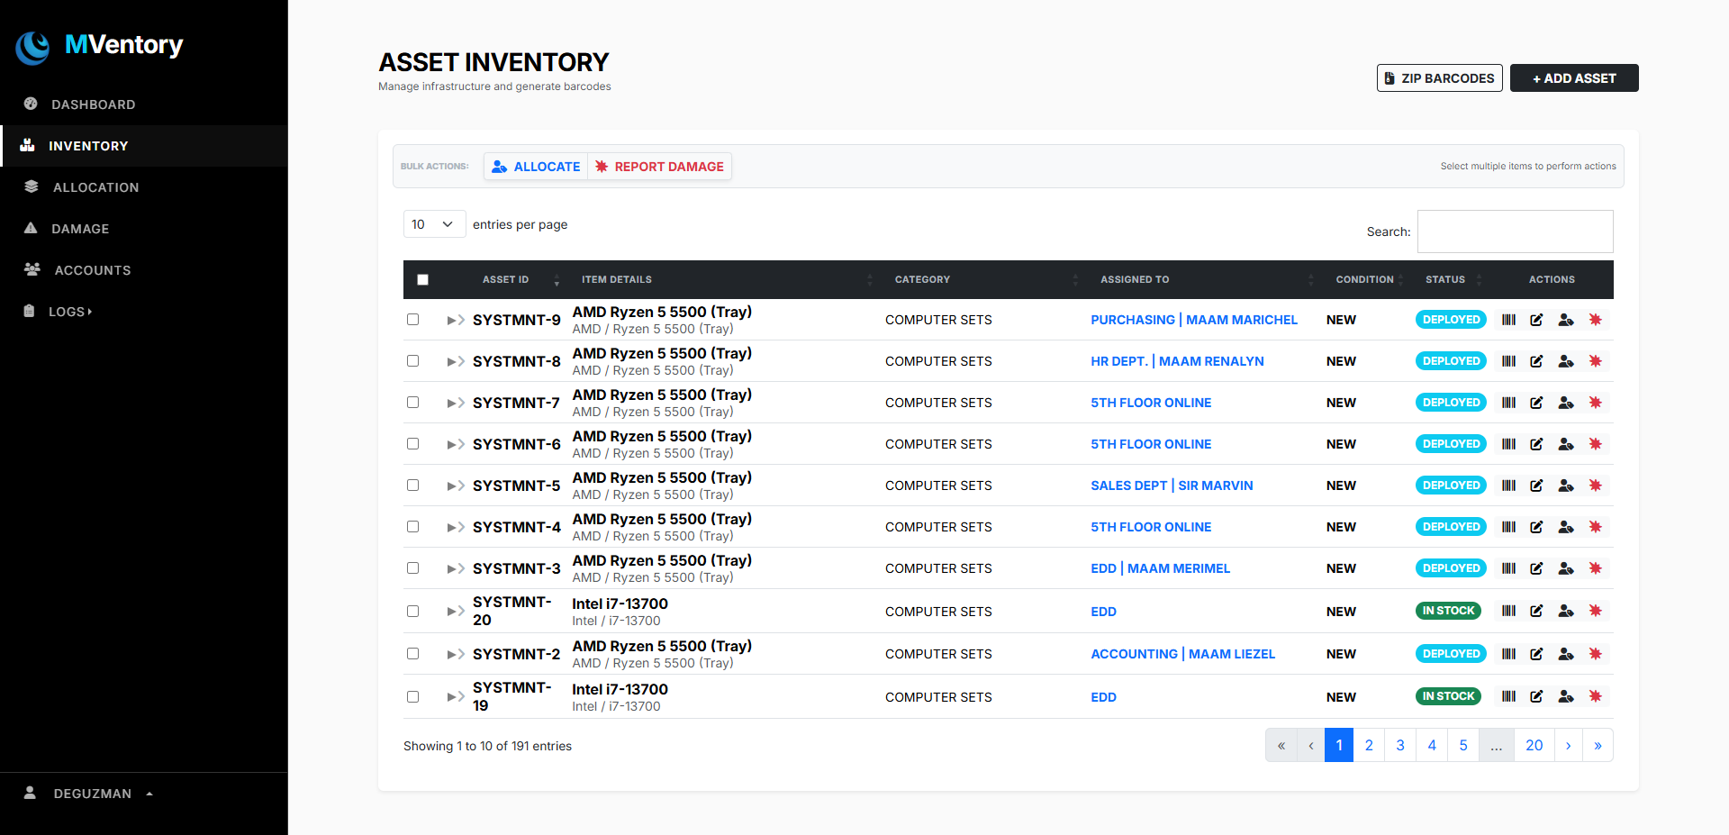
Figure: 2.1: Inventory Section.

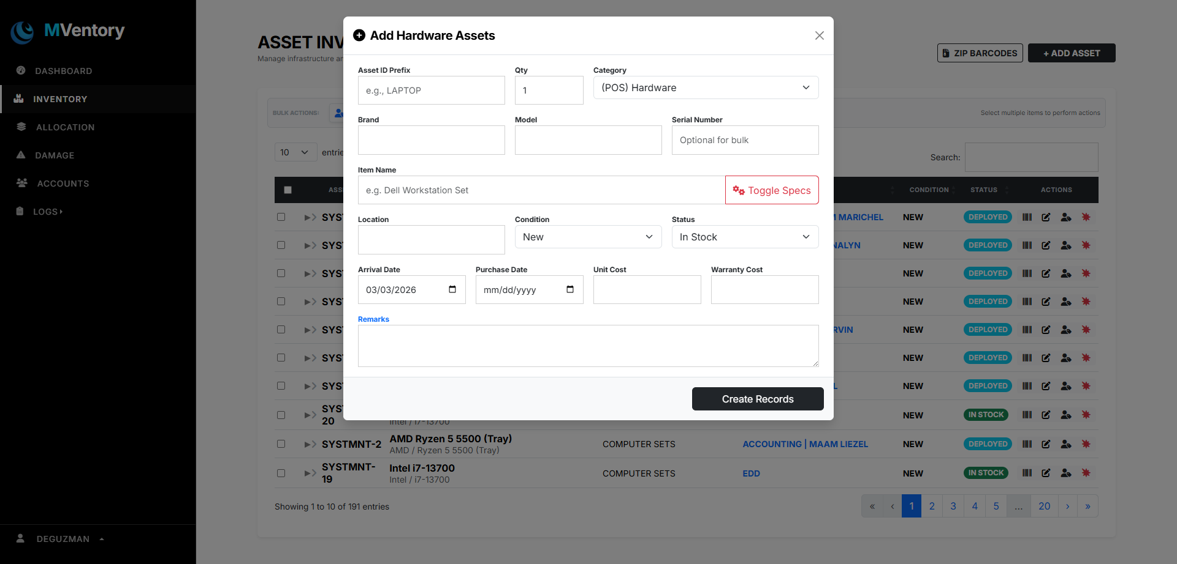
Figure: 2.2: Adding asset to inventory.

Deploying an Asset
- Open asset record
- Click Allocate
- Change:
  - Assigned To
  - Status → Set to "Deployed"
  - Set transfer date
- Click Update

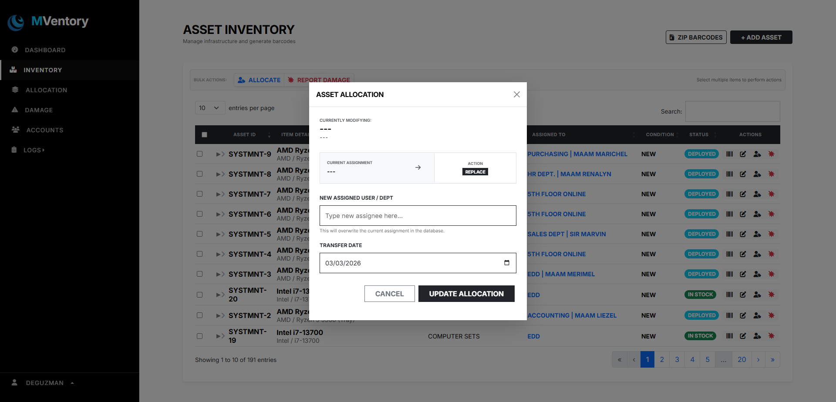
Figure: 3: Allocating assets.

Updating Asset Condition
- Open Inventory
- Click Edit
- Update condition (e.g., Repaired, etc.)
- Save changes

Searching Assets
- Use search bar
- Filter by category or location
- Results auto-display

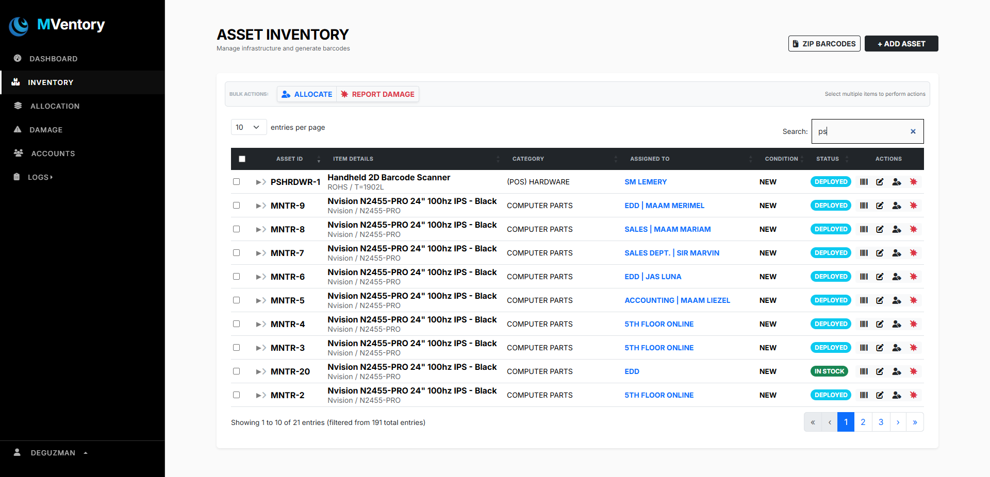
Figure: 4: Searching assets.

TROUBLESHOOTING GUIDE
Problem | Possible Solution
Cannot connect to database | Check render/connection.php
Assets not saving | Check required fields
Page not loading | Restart Apache/MySQL
Login issue | Verify user credentials in database

MAINTENANCE GUIDE

9.1 Database Backup
- Open phpMyAdmin
- Select mventory_db
- Click Export
- Save SQL file
Recommended: Weekly backup

9.2 Updating System
- Always backup database before modifying code
- Test changes in local environment first
- Maintain version number updates

CHANGE LOG
Version | Date | Changes
v1.0 | Jan 6, 2026 | Initial Development
v2.0 | Feb 2026 | Deployment Monitoring Added
v2.2.6 | Mar 2, 2026 | Performance Improvements & UI Enhancements

SECURITY NOTES
- Passwords are encrypted in database.
- Database credentials stored in config file.
- Direct access to sensitive folders should be restricted.
- Only authorized IT personnel should access admin panel.

FUTURE IMPROVEMENTS
- Barcode/QR scanning integration
- Asset movement history log
- Automated reporting
- Email notifications
- Role-based access control

DEVELOPER NOTE
This system is continuously improving and may undergo feature updates and structural enhancements for scalability and security.

